# Sprint 1 Plan: SlugManager

Team: Asher Etherington, Kenneth Losier, Mia Santos, Nathan Le, Poppy Garner, Gino Zarich

Sprint Completion date: 4/24/24

Revision Number and Date:

## Goals:

The app must cater to both administrators and team members, granting distinct permissions. Administrators manage task creation, deadlines, and assignments. Team members can update their progress, add attachments/comments, and access a dashboard displaying their assigned tasks, progress, and deadlines.

## Task Listing:

User Story 1 [SLUG-1]:

As a user, I want to be able to store my account information in a database so that I can access it later.

* Task 1 [SLUG-2]: find a free mongodb server service to use and use it to create a complete database with a simple schema for our app in order to store account logins and passwords (time estimate: 8 hours)
* Task 2 [SLUG-3]: create a javascript file and use it to test connection to the created database(time estimate: 2 hours)
* Task 3 [SLUG-4]: Generate html file to create a screen in which users can input their account information, or creation page (time estimate: 4 hours)
* Task 4 [SLUG-5]: Account creation that takes email and password. Possibly a password confirmation when creating an account use javascript to store in database (time estimate: 3 hours)
* Task 5 [SLUG-6]: Account sign in based on email and password. Email and hashed password stored in database. (time estimate: 2 hours)

Total for user story: 19 hours

## Team Roles:

Asher Etherington: Team Member

Kenny Losier: Team Member

Mia Santos: Team Member

Nathan Le: Team Member

Poppy Garner: Scrum Master

Gino Zarich: Project Owner

## Initial Task Assignment:

Asher Etherington: Task 1+2

Kenny Losier: Task 5

Mia Santos: Task 3

Nathan Le: Task 4

Poppy Garner: Task 4

Gino Zarich: Task 1+2

## Initial Burnup Chart:

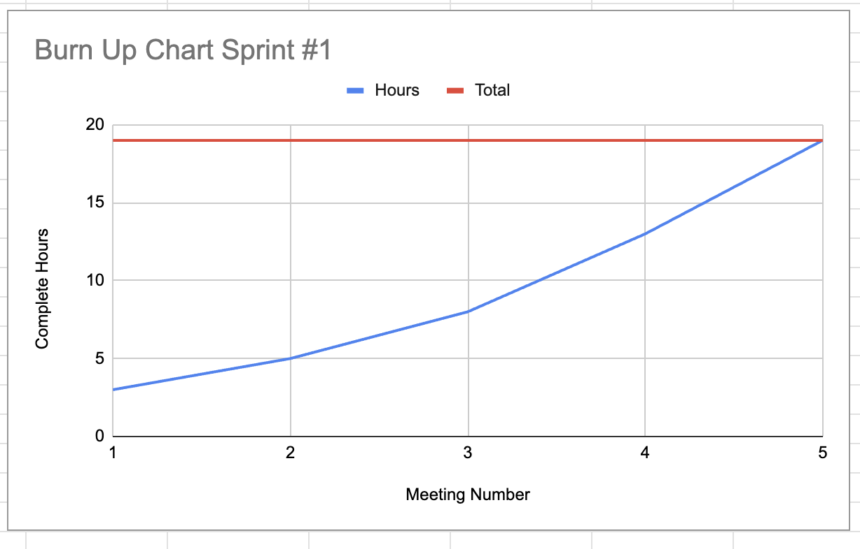

## Initial Scrum Board:

## Scrum Times:

Monday: Team Meeting 9:15-10:15 AM

Tuesday: Meeting with TA 2:15-3:15 PM

Wednesday: Team Meeting 9:15-10:15 AM

Friday: Team Meeting 9:15 - 10:15 AM